ACFM-948

17th Asian Congress of Fluid Mechanics (ACFM), August 8-12, 2023 in Beijing, China.

**Bulk rise in the interstices of capillaries** – Response to referees

Chitransh Atre, Aditya Manoj and Baburaj A. Puthenveettil

***General Comment***

We thank the reviewers for reviewing the manuscript, for providing helpful comments and for their positive recommendation. All the figures and equation numbers now refer to those in the revised manuscript. Also, all the changes and additions are indicated in red in the revised manuscript.

***Reviewer 1***

|  |
| --- |
| *This manuscript investigates liquid capillary rise in interstices created by three circular capillaries by experiments. Two distinct phases of visco-inertial and visco-gravitational regimes are found during capillary rise. The corresponding scaling analysis is carried and verified with experiments. The results help further understand the dynamics of capillary rise. I would like to accept this paper with minor edits and revisions:* |

|  |
| --- |
| 1. *What is the material of the capillary bundles? And what is the actual static value of contact angle?*   The material of the capillary bundles is borosilicate glass. The value of static contact angle for glass and water combination is 43° [1]. We also have measured the equilibrium contact angle for borosilicate glass - DI water combination at the room temperature which was 45°.  [1] Haghanifar, S., Lu, P., Kayes, M. I., Tan, S., Kim, K. J., Gao, T., Ohodnicki, P., & Leu, P. W. Self-cleaning, high transmission, near unity haze OTS/silica nanostructured glass. *Journal of Materials Chemistry C*; 2018 : *6*(34), 9191–9199. <https://doi.org/10.1039/c8tc02513d>   1. *Ttemperature in experiments is needed since the properties of water is sensitive to environmental temperature.* |

The temperature while doing the experiments is kept at room temperature 25° C. We have measured the surface tension value for water using Tensiometer at this temperature.

***Reviewer 2***

|  |
| --- |
| *The authors derived the equation for capillary rise based on force balance, and performed experiments to verify their theory. The problem is not quite new, but this investigation is still of interest. I have a few questions for the authors, and suggest them to carefully check the manuscript again and make a revision.* |

1. *I recommend using an objective when taking image to promote image resolution. In the manuscript, the authors should tell us the pixel size etc. More importantly, how to precise measure the position of the meniscus is key to compare with theory.*

We have added the pixel size details in the revised manuscript. We recorded the video at 60 fps for capturing the capillary rise phenomena. We extracted the frames from the video using MATLAB. Each frame is of (1920 x 1080) pixels size. The meniscus covers a range of pixels from light to dark. Since we zoomed up the image and then selected the dark pixel which corresponds to the bulk meniscus, the error will be very less for measuring the height.

1. *Related to question 1, I am curious why did the authors use an unconventional cross-section shape of the interstice, which is very difficult for optical observation. In particular, in the theoretical analysis, I do not see the contribution of the shape of interstice, which means the theory is for general cases like a capillary with round cross-section. This issue weakens the novelty of this study.*

We are using the corner of the interstice to increase the rate of capillary rise. The bundles of capillary tubes will be used in the heat pipe. In the theoretical analysis, the area, and the curvature length of the interstice is used which is different from the circular capillary.

1. *Is eq (13) similar to the Washburn equation?*

No. Eq (13) is different from the Washburn equation. The Washburn equation is given by $h(t)=\sqrt{\frac{Rσ \left(\cos{θ}\right)t}{2μ}}$ in which $h\left(t\right)α \sqrt{t}$, whereas in our case for interstice, the equation is given by $h(t)=t\sqrt{\frac{6.25πσcos⁡θ}{ρR}}$.

1. *There are many mistakes/typos in the current version, please check carefully and revised them. For example, in the second line of abstract, “employedused”; in page 3, the line below eq 6, the comma should be removed; on the right-hand side of eq (12), a “)” is missing; in page 4, the line above eq (18), what is “in the form (15) in the form”?*

We have corrected the mistakes/typos in the revised manuscript. The corrections are highlighted in red colour.

**BULK RISE IN THE INTERSTICES OF CAPILLARIES**

Chitransh Atre1, Aditya Manoj2, Baburaj A. Puthenveettil3

1 Department of Applied Mechanics, Indian Institute of Technology Madras, Chennai 600036, India   
2 Department of Mechanical Engineering, IIITDM Kancheepuram, 600127, India

†Email address for correspondence:: [chitransh.atre@gmail.com](mailto:chitransh.atre@gmail.com)

**Keywords**: BULK MENISCUS, VISCO-INERTIAL REGIME, VISCO-GRAVITATIONAL REGIME

Abstract

In this paper, we measured the capillary rise in the interstices created when three circular capillaries were joined together. We used different sizes of circular capillaries with outer diameters of $700 μm,1380 μm,5000 μm$, and 10000 $μm$ and focused on the bulk meniscus rise. We found two distinct phases during the capillary rise, a visco-inertial regime and a visco-gravitational regime. To complement our experimental findings, we propose a novel scaling analysis for the capillary bulk meniscus growth in these regimes. In the visco-inertial regime, we developed the relation as $h^{2}(t)=(2b/a)(t-(1/a)(1-exp⁡(-at)))$, where , $a=(μπ)/\left(ρR^{2}\right)$ and $b=(πσcos⁡θ)/(ρR)$. While in visco-gravitational regime, we find the solution as $h(t)=(c/d)\left(1+W\left(-exp⁡\left(-1-\left(d^{2}t\right)/c\right)\right)\right)$ where, $c=\left(σcos⁡θ/(μ)\right.$ and $d=\left(ρgR^{2}\right)/(πμ)$ and $W$ is the Lambert function. We found that the experimental data collapses on to the analytical solution which was plotted in dimensionless form. We now have a better understanding of the dynamics of capillary bulk rise in interstices, which has significant repercussions for a variety of processes, both natural and industrial.

1 Introduction

The phenomenon of capillary rise has major practical applications in a variety of industries, including oil recovery, civil engineering, dyeing textiles, ink printing, lithography, and even in DNA translocation. It is essential to have a solid understanding of the dynamics of the meniscus found in the capillary tubes as well as the penetration of wetting fluids into confined spaces such as interstice.

It is possible for liquids to demonstrate a variety of geometric wetting conditions as they pass through irregular conduits, complex surfaces, and materials that are porous. This indicates that various components of the flow may move at different speeds, despite the fact that they are subjected to the same conditions imposed by the capillary pressure. This idea can be applied to rethink the age-old problem of abrupt capillary rise in tubes that have interior corners, and it can result in helpful analytical answers to the problem. Lucas and Washburn in 1921 [1] developed an analytic explanation of liquid rise in a capillary tube. This model does not take into account the influence of inertia, nor does it take into account the presence of liquid within the meniscus. They verified the theoretical results with experimental results for different liquids e.g. water, mercury and found that the bulk meniscus height is proportional to square root of time.

Ichikawa et al. [2] investigated the dynamics of liquid motion in a capillary tube as a result of the action of capillary force alone, without taking into account the effects of gravity. The studies were carried out by positioning a tube in a horizontal position, and the findings were examined theoretically using a non-dimensional approach. In the year 2000, Zhmud et al. [3] presented a comprehensive summary of the solutions for a variety of time regimes, and they found asymptotic solutions for both short and long periods of time. Dong and Chatzis [4] investigated the behaviour of the flow of a wetting liquid in a capillary with a square cross section by employing a variety of liquids with varying levels of viscosity and surface tension. They concentrated on the flow that was occurring in the corner of the square capillary and found that the imbibition rates are proprtional to $(σ/μ)^{1/2}$.

Fries and Dreyer [5] and [6] explored the dynamics of rise in the circular capillary tube by balancing between the viscous force, inertial force and gravitational force with the capillary force. They developed the analytical equations for determining the height of the bulk meniscus as the function of time for different regimes. In addition to this, they demonstrated how the height of the circular capillary tube changed over the period of time. The experimental investigation of the kinetics of capillary rise in tubes with varying cross sections was carried out by Heshmati et al. [7] in 2014. In addition to this, they discussed the flow behavior in relation to the dynamic contact angle. The dynamic contact angles measured for circular tubes were employed to derive rise-versus-time values that exhibit a stronger agreement with the corresponding experimental data compared to the predictions obtained from the Washburn equation, which assumes a constant contact angle.

The interstices that is created between a collection of tubes or rods are the geometry that occurs most frequently with circular regions and corners. In the current investigation, we carried out the experiments to determine the amount of liquid that accumulates in the interstice with time. The objective of this study is to find the several stages of capillary rise as well as the transitions that occur between those stages. According to the momentum balance of a liquid contained within an interstice tube, the hydro-static force, the viscous force, and the inertial force must all be in balance with surface tension force. We took an assumption that there are no entrance or inertia effects in the liquid reservoir and the Hagen-Poiseuille rule governs the viscous pressure loss inside the interstice. In addition, it is presumed that there is no change in the capillary pressure, which is determined by employing the tube radius $R$ and a static contact angle in the calculation $θ$.

**2 Experimental Setup**

We employ circular capillaries with outer diameters of 700 $μm,1380μm,5000μm$, and $10000μm$ for our experiments. A diagrammatic representation of the apparatus used for the experiments is shown in figure 1. To make the three cornered interstice, depicted in figure 2 (a), we used three borosilicate circular glass tubes, each of which was 10 centimetres in length. These tubes were held together by heat-shrink sleeves. The interstice's cross-sectional region is shown in figure 2. For the purpose of visualising the ascent of liquid in this interstice, we utilised water with blue ink mixed in it. Table 1 provides the properties of water. The capillary bundle was secured in a vertical position, and with the assistance of a vertical traverse, the container containing DI water combined with ink was gradually brought into contact with the lower portion of the capillary bundle. When the bottom of the capillary makes contact with the free surface of the water, water begins to rise in the interstice. The bulk fluid first rises at high speeds, but the rate of ascent continues to decrease till the bulk meniscus reaches a height where it is in equilibrium. The videos of this ascent were captured using a NIKON D5300 camera at 60 frames per second using a TAMRON Macro lens with a focal range of 180-400 millimeters. Each frame extracted from the video is of (1920 x 1080) pixels size. Back illumination was accomplished with the help of an green LED light source of $532 nm$.

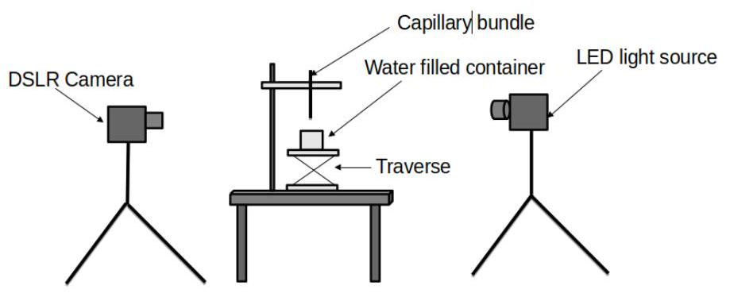

Figure 1: Schematic representation of experimental setup

(a)

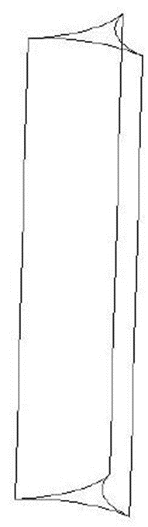

(b)

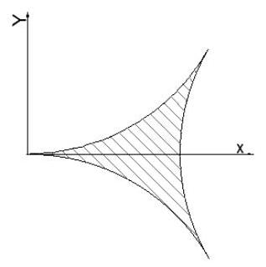

Figure 2: (a) 3-D view of interstice (b) Cross-section of the interstice

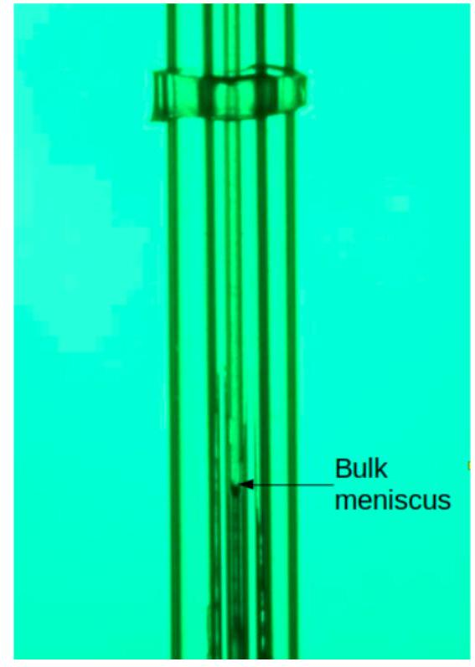

Figure 3: Image of bulk meniscus inside the interstice

The capillary height of the bulk in the interstice of each bundle was measured as a function of time from the videos. The Figure 3 shows an image frame of rise of liquid inside an interstice created by three circular capillaries of $1380μm$ outer diameter. The bulk meniscus and the corner meniscus tip can be seen in zoomed image.

3 Methodology

*3.1 Balancing the forces*

By balancing the element forces, we can get the equation that describes the change in bulk meniscus height over the course of time. The interstice cross-section consists of three circular capillaries of radius $R$ as its boundary surfaces. The area of the cross section of the interstice is obtained from this geometry as:

$A=(\sqrt{3}-π/2)R^{2}.$ (1)

The wetting perimeter, is the circumferential length which is denoted by $C$,

$C=πR,$ (2)

The Laplacian pressure force is given by the product of surface tension and over the circumferential length, given by

$F_{D}=σcos⁡θπR.$ (3)

The inertial force, $F_{I}$, is given by

$F_{I}=\frac{∂}{∂t}[mv]$ (4)

where, the velocity can be written as

$v=\frac{∂h}{∂t}$ (5)

and the mass,

$m=ρAh,$ (6)

with $h$ being the bulk meniscus height in the interstice. Substituting (5) and (6) in (4), we obtain

$F_{I}=\frac{d}{dt}\left[\frac{dh}{dt}ρ(\sqrt{3}-π/2)R^{2}h\right].$ (7)

Gravitational force is given by

$F_{G}=ρgAh$ (8)

while the viscous force, assuming that the flow inside the interstice similarly follows Hagen-Poiseuille flow, is

$F_{V}=ΔPA=8πμh\overset{˙}{h},$ (9)

where $\overset{˙}{h}$ denotes $dh/dt$.

Then, balancing all the forces in the interstice, we obtain

$F_{I}=F_{D}-F_{V}-F_{G}.$ (10)

Substituting (3), (4), (8) and (9) in (10) and re-arranging, we get,

$\frac{6.25πσcos⁡θ}{R}=ρ\frac{d(h\overset{˙}{h})}{dt}+\frac{50πμh\overset{˙}{h}}{R^{2}}+ρgh.$ (11)

*3.2 Purely inertial regime*

In purely inertial regime, we neglect the gravitational and viscous term in (11) to obtain

$\frac{6.25πσcos⁡θ}{R}=ρ\frac{d(h\overset{˙}{h)}}{dt}$ (12)

Integrating (12), we get,

$h=t\sqrt{\frac{6.25πσcos⁡θ}{ρR}}$ (13)

*3.3 Visco-inertial regime*

Neglecting the gravity term in (11).

$\frac{6.25πσcos⁡θ}{R}=ρ\frac{d(h\overset{˙}{h})}{dt}+\frac{50πμh\overset{˙}{h}}{R^{2}}.$ (14)

Solving (14) analytically for $h$, we obtain

$h^{2}=\frac{2b}{a}\left[t-\frac{1}{a}(1-exp⁡(-at))\right],$ (15)

where, $a=(50πμ)/\left(ρR^{2}\right)$ and $b=(6.25πσcos⁡θ)/(ρR)$.

*3.4 Visco-gravitational regime*

We neglect the inertia term in (11) to obtain,

$\frac{6.25πσcos⁡θ}{R}=\frac{50πμh\overset{˙}{h}}{R^{2}}+ρgh$ (16)

Solving (16) for $h$, we get,

$h(t)=\frac{c}{d}\left[1+W\left(-exp⁡\left(-1-\frac{d^{2}t}{c}\right)\right)\right]$ (17)

where $c=(σRcos⁡θ)/(8μ)$ and $b=\left(ρgR^{2}\right)/(50πμ)$ and $W$ is the lambert function.

**4 Results**

The variation of the bulk meniscus height in the interstices of capillary bundles of various radius $R$ with time $t$ is plotted in 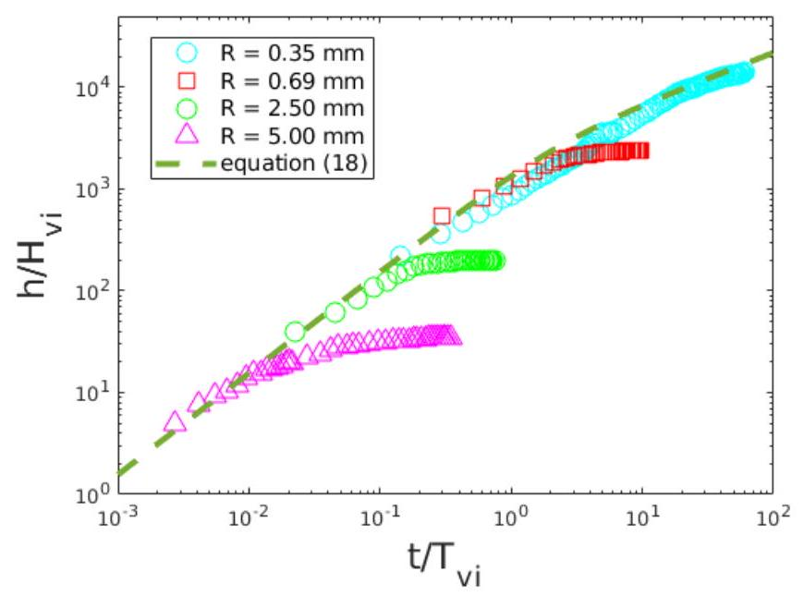figure 4 . It can be seen that at any time the bulk height is larger as the radius of the capillary decreases. The final bulk height, which is independent of time is also higher for the smaller radii capillaries. The rate of increase of the bulk meniscus height is larger, with decrease in $R$. Table 1 shows the properties of water used. The contact angle value refers to the static value used for theoretical computations [8].

Table 1: The values of the properties of water

|  |  |  |  |
| --- | --- | --- | --- |
| $$σ(N/m)$$ | $$μ(Pa-s)$$ | $$ρ\left(Kg/m^{3}\right)$$ | $$θ(deg)$$ |
| 0.071 | $$8.4*{10}^{-4}$$ | 997 | 45 |

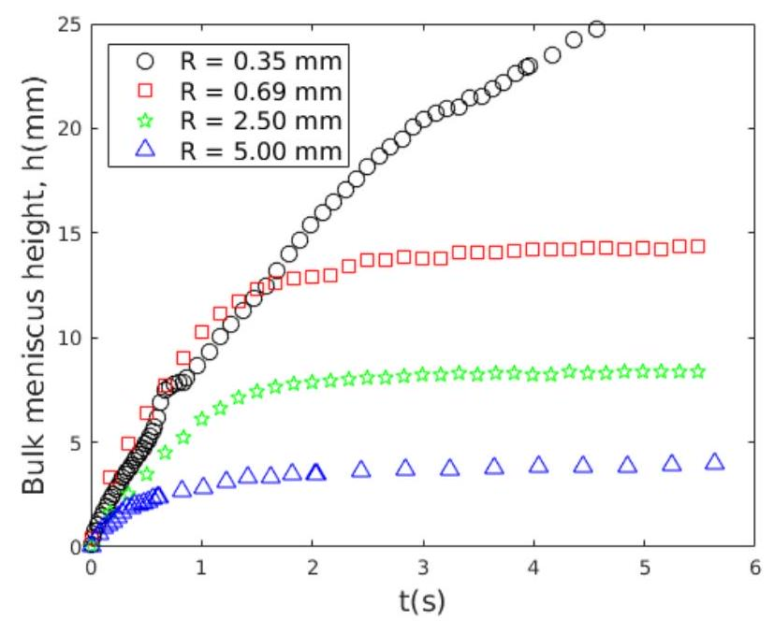

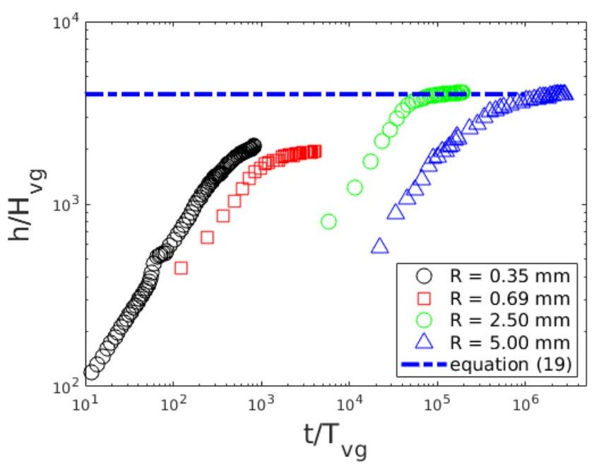Figure 4: Variation of the bulk meniscus height with time in interstices of different radii capillaries.

Figure 5 shows the variation of the dimensionless height, $h/H_{vi}$ with the dimensionless time, $t/t_{vi}$. The analytical relation (15) in the form

$\frac{h}{H_{vi}}=2\left(\frac{t}{T_{vi}}-\left(1-exp⁡\left(-\frac{t}{T_{vi}}\right)\right)\right)$ (18)

is plotted along with the experimental data in figure (5). The initial variation of the experimental data for different capillaries collapse on to visco-inertial regime curve.

Figure 6 shows the variation of $h/H_{vg}$ with $t/T_{vg}$, where $H_{vg}=(σcos⁡θ)/(ρgR)=c/d$ is the characterstic length scale in the visco-gravitational regime and $T_{vg}=$ $(μσcos⁡θ)/\left(ρ^{2}g^{2}R^{3}\right)=c/d^{2}$ is the corresponding characteristic time scale.

Figure 5: Scaling of the bulk meniscus height for the initial time periods.

Figure 6 also shows (17) in the form

$\frac{h}{H_{vg}}=1+W\left(-exp⁡\left(-1-\frac{t}{T_{vg}}\right)\right)$ (19)

For the later time period when the bulk meniscus height becomes independent of the time, the experimental data for the two bigger diameter capillaries collapse on to (19). The data for the smallest capillary interstice data did not have sufficient time span to cover. The offset of the data of $R=0.69 m$ capillary is expected to be due to the experimental error due to change of wetting conditions.

Figure 6: Scaling of the bulk meniscus height for the later time periods

**5 Conclusions**

The paper finds two distinct regimes in the transient rise of the bulk meniscus in the interstice of capillaries, viz. the visco-inertial regime in the initial times and the visco-gravitational regime in the later times. Scaling laws were developed for the transient height of the bulk meniscus in the interstice for each of those regimes, based on the relevant force balances. The experimental data collapsed on to these scaling laws, thereby validating those relations.

**6 Acknowledgements**

We would like to express our gratitude to the Department of Science and Technology of the Government of India for support through the project IMP/2018/001167, CRG/2021/007497. We would like to thank Usha P Verma Sc 'G, Advanced Systems Laboratory (ASL), the Defense Research and Development Organization (DRDO), and Astra Microwave Products Ltd. for their cooperation.

**7 Nomenclature**

$A=$ Area of interstice cross section $\left(m^{2}\right)$

$C=$ Circumference $(m)$

$g=$ Acceleration due to gravity $\left(\frac{m}{s^{2}}\right)$

$ρ=$ Density of liquid $\left(\frac{kg}{m^{3}}\right)$

$μ=$ Dynamic viscosity $(Pa-s)$

$θ=$ Contact angle (degrees)

$h=$ Bulk meniscus height $(m)$

$T=$ Time $(s)$

$W=$ Lambert function $(-)$

$R=$ Radius of the capillary tube $(m)$

$T_{vi}=$ Time scale for visco-inertial regime $(s)$

$T_{i}=$ Time sclae for inertial regime $(s)$

$T_{vg}=$ Time sclae for visco-gravitational regime $(s)$

$H_{vi}=$ Length scale for visco-inertial regime $(m)$

$H_{i}=$ Length scale for purely inertial regime $(m)$

$H_{vg}=$ Length scale for visco-gravitational regime $(m)$

**8 References**

1. Edward W. Washburn, Dynamics of capillary flow., The Physical Review, 1921; 3:273-283.
2. Naoki Ichikawa, Yoko Satoda, Interface dynamics of capillary flow in a tube under negligible gravity condition, Journal of Colloid and Interface Science,1994;162:350-355.
3. B.V. Zhmud, F. Tiberg, K. Hallstensson, Dynamics of capillary rise., Journal of Colloid and Interface Science,2000; 228:263-269.
4. M. Dong, I. Chatzis, The imbibition and flow of a wetting liquid along the corners of a square capillary tube, Journal of Colloid and Interface Science,1995; 172:278-288
5. N. Fries, M. Dreyer, An analytic solution of capillary rise restrained by gravity, Journal of Colloid and Interface Science,2008; 320:259-263.
6. N. Fries, M. Dreyer, The transition from inertial to viscous flow in capillary rise, Journal of Colloid and Interface Science, 2008; 327:125-128
7. Mohammad Heshmati, Mohammad Piri, Experimental investigation of dynamic contact angle and capillary rise in tubes with circular and noncircular cross sections, Langmuir, 2014; 30:14151-14162
8. Haghanifar, S., Lu, P., Kayes, M. I., Tan, S., Kim, K. J., Gao, T., Ohodnicki, P., & Leu, P. W. Self-cleaning, high transmission, near unity haze OTS/silica nanostructured glass. Journal of Materials Chemistry C, 2018; 6(34): 9191–9199.